**Design and Implementation of an Embedded Edge-IoT System for Dynamic Emergency Lane Clearance in Urban Traffic Using Thermal and Humidity-Aware Vision**

Author:- Parthiban G  
Ph.No:-9843777061  
email:-727823tuio035@skct.edu.in  
college:-Sri Krishna College Of Technology

Author:- Prem S  
Ph.No:-8778642535  
email:-727823tuio039@skct.edu.in  
college:-Sri Krishna College Of Technology

Author:- Shakhib Akthar S  
Ph.No:-9600338108  
email:-727823tuio045@skct.edu.in  
college:-Sri Krishna College Of Technology

**Abstract:** Emergency cars face main difficulty from the unexpected rise in city traffic. Congestion on roads and the lack of smart traffic lane control could make it very delayed. The present work addresses real-time emergency lane clearing support using a newly Embedded Edge-IoT system designed and used. It is founded on the most recent developments in vision systems on chips, Internet of Things (IoT), and Artificial Intelligence (AI). The new system reacts quickly to weather conditions like fog, rain, and low visibility using thermal cameras and humidity sensors. Our system processes traffic data in real-time using edge computing. To spot emergency cars, it has real-time sensors, thermal cameras, and conventional cameras. The system will automatically switch into thermal vision or infrared modes depending on temperature and humidity if the weather is poor, so it can still detect and follow. Traffic lights are controlled by the system using artificial intelligence. By means of traffic light timing optimization depending on the number of cars, speed, and road occupancy, it benefits emergency vehicles. City areas have been simulated with the solution.Forecasting approaches including LSTM and ARIMA were used to simulate it to forecast traffic behavior. Even in bad weather, experimental findings reveal significant response time decrease and better traffic flow. The work confirms the building of smart city infrastructure enabling responding services to react quicker, interact more effectively with the environment, and support better urban transportation.

Keywords:AI; IoT; Edge Computing; Adaptive Traffic Control System (ATCS); Predictive Analytics; Emergency Vehicles; Thermal Vision; Humidity Sensors; Time-Series Forecasting; Urban Mobility; Smart Cities; Embedded Systems; Real-Time Traffic Management

**1.Introduction**

**1.1 Background on AI and IoT in Urban Mobility**

Urbanization proceeds at an exceptional pace around the world, driving to expanding challenges in overseeing transportation foundation successfully. With over half of the worldwide populace presently living in cities, the request for effective urban portability frameworks has never been higher. Customary activity administration techniques depending on fixed-time flag plans and manual checking have gotten to be insufficient for adapting with the energetic, complex, and regularly eccentric nature of present day urban activity designs. The appearance of the Web of Things (IoT) has presented transformative conceivable outcomes within the way cities accumulate and utilize information. IoT alludes to the organize of interconnected physical gadgets implanted with sensors, communication modules, and computing capabilities that empower persistent information securing and real-time observing. In urban versatility, IoT gadgets such as vehicle counters, reconnaissance cameras, discuss quality sensors, and keen activity signals give broad perceivability into the current state of activity stream and natural conditions. Parallel to IoT, Counterfeit Insights (AI) technologies—particularly machine learning (ML) and profound learning (DL)—have appeared momentous capabilities in extricating significant bits of knowledge from tremendous datasets. AI calculations can distinguish complex activity designs, anticipate clog buildup, and suggest or actualize optimized control activities with negligible human mediation. The cooperative energy of AI and IoT empowers the advancement of shrewdly transportation frameworks (ITS) that advance from responsive activity control to prescient and versatile activity administration. The integration of AI and IoT is urgent for tending to basic urban versatility challenges, counting activity clog, mishap diminishment, contamination control, and proficient crisis reaction. AI-enabled IoT frameworks encourage the collection of real-time information, neighborhood preparing through edge computing, and cloud-based analytics for long-term arranging. Together, these advances guarantee to revolutionize urban transportation by empowering more brilliant, more secure, and more feasible portability 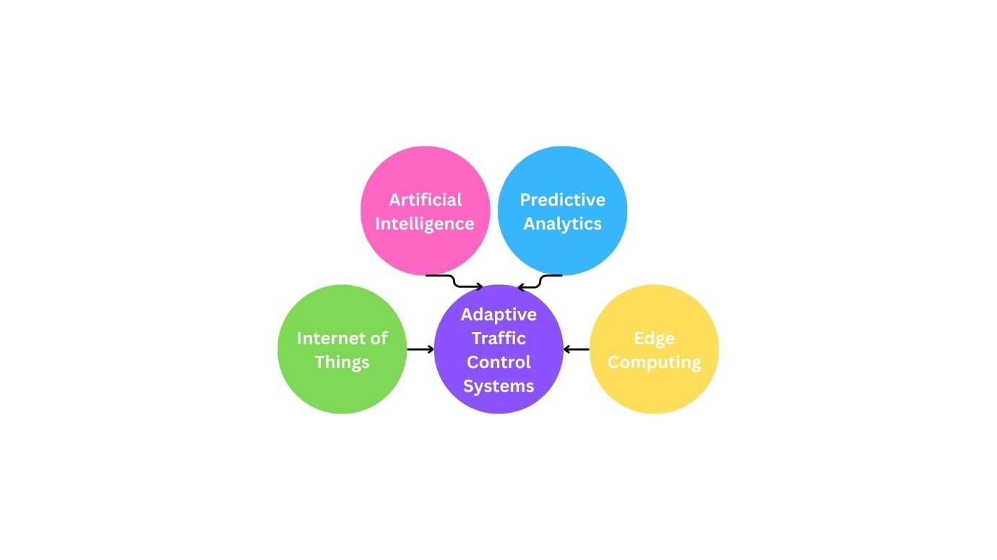arrangements.

**Fig. 1.** *Integration of Artificial Intelligence, IoT, Predictive Analytics, and Edge Computing in the Development of Adaptive Traffic Control Systems.*

**1.2 Role of Real-Time Traffic Management in Smart Cities**

Real-time activity administration is an basic component of keen city framework, contributing to the upgrade of urban livability and maintainability. Savvy cities use data-driven decision-making to optimize asset utilize, make strides benefit conveyance, and lock in citizens in more compelling urban administration. Inside the setting of activity administration, real-time frameworks give ceaseless observing and energetic control of activity signals, path allotments, and occurrence discovery components. Conventional activity flag controllers ordinarily work on pre-programmed plans that cannot adjust to sudden activity variances or crises, coming about in wasteful activity stream, expanded travel time, and raised emanations. Real-time versatile activity administration frameworks depend on IoT sensors sent at key areas such as convergences, thruways, and blood vessel streets. These sensors capture information on vehicle tallies, speed, inhabitance, and natural variables like climate and perceivability. Progressed communication systems, counting 5G and adherent joins, empower consistent information transmission between field gadgets and control centers. Real-time activity information is prepared utilizing AI calculations to powerfully alter activity flag timings, actualize need paths, and facilitate different convergences in a activity hallway. Such versatile control not as it were reduces blockage but moreover encourages need section for crisis vehicles and open transportation, decreasing delays and moving forward by and large activity security. Edge computing has developed as a key enabler for real-time activity administration by decentralizing information handling closer to the source. This decreases idleness and transfer speed prerequisites compared to cloud-centric structures, permitting near-instantaneous response to activity occasions. The sending of inserted AI-capable edge gadgets encourage upgrades the flexibility and versatility of activity administration frameworks, making them more appropriate for the thick and heterogeneous situations characteristic of urban regions.

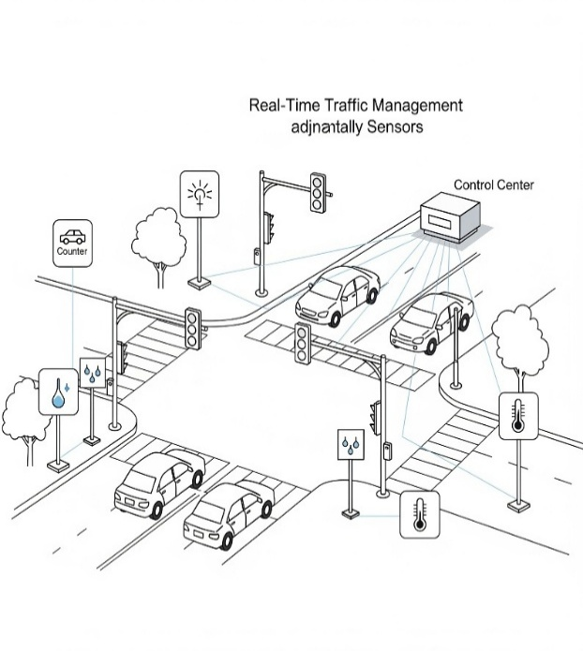

**Fig. 2.** *Simple real-time traffic signal adjustment using sensor data in a smart city intersection. were generated by AI*

**1.3 Motivation for Adaptive Signal Control Using AI and Sensor Data**

The inspiration for creating adaptive signal control frameworks is established within the restrictions of conventional activity control strategies and the expanding complexity of urban activity. Fixed-time activity signals are frequently based on authentic information and straightforward heuristics, which fail to capture real-time varieties caused by occasions such as accidents, roadworks, or climate conditions. This comes about in inefficient signal timings, longer lines, and increased risk of collisions and outflows. Adaptive signal control frameworks utilize sensor information from numerous modalities to pick up a comprehensive and exact understanding of the activity environment. For occurrence, vision-based sensors can distinguish vehicle presence and classify vehicle types, but their adequacy reduces in low-visibility conditions such as fog, rain, or smoke. To overcome this, the integration of warm imaging and natural sensors, such as humidity detectors, provides complementary information that improves vehicle discovery strength under unfavorable climate. Artificial intelligence methods, including supervised and support learning, empower the framework to analyze multi-sensor information, learn activity designs, and foresee near-future activity conditions. These capabilities permit the activity control system to proactively adjust signal timings and manage path assignments, subsequently optimizing throughput and minimizing delays. Particularly, in crisis scenarios, adaptive signal control can encourage energetic crisis path clearance, giving need section to ambulances, fire trucks, and police vehicles. Recent progresses in inserted AI and edge computing equipment have made it feasible to send advanced AI models specifically inside traffic signal controllers. This minimizes communication delays and enables real-time, localized decision-making. The system can also communicate with cloud platforms for long-term analytics, show upgrades, and integration with broader smart city frameworks. This research proposes a novel embedded Edge-IoT design combining warm and humidity-aware vision sensors with AI-driven adaptive traffic signal control to address urban traffic management challenges successfully. The proposed framework points to progress traffic flow efficiency, security, and environmental maintainability by providing a solid, real-time, and weather-resilient arrangement that supports dynamic emergency path clearance in congested urban situations.

**2. IoT in Smart Traffic Systems**

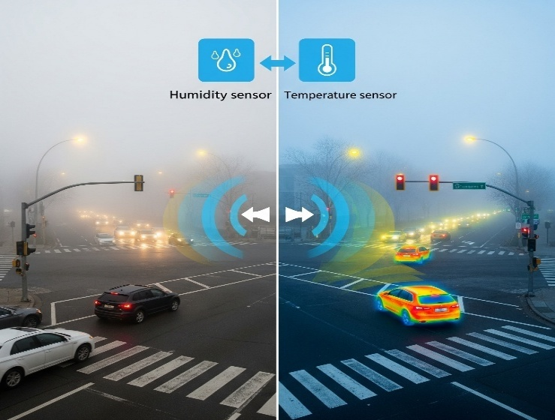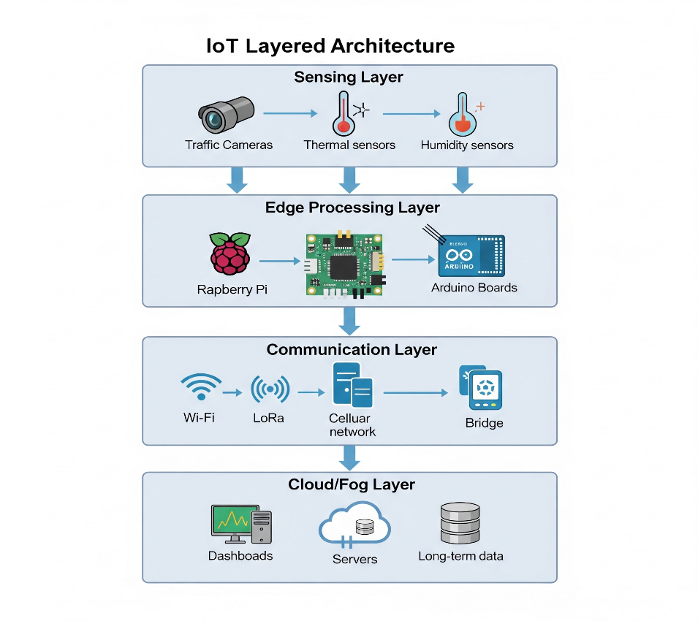The integration of the Internet Of Things(IOT) into city traffic system massive development in the modernization of city Infrastructure, focused on addressing the increase in vehicular congestion ,road safety, and handling emergency situation. With a continuous increase in urbanization, traditional traffic management systems couldn’t handle the rapid and unpredictable traffic movement in the current scenario. IOT provides a solution by enabling real-time communication among such gadgets like sensors, cameras controllers, and processing units. This enables the city infrastructure to work smarter and adapt according to the situation. During emergencies, when immediate action and priority signals are required, IOT based traffic management system can save lives and minimize traffic congestion.IOT framework architecture for city traffic system is generally a layered based setup, consisting of data collecting devices,processing nodes in most cases, edge-based communication protocols, and cloud-based centralized support for the storage and qualitative analysis.

**Fig. 1*.*** *IoT Framework Architecture for Smart Traffic System were generated using AI*

In the sensing layer the outer data related to the environment and vehicles are accessed through traffic cameras, infrared and thermal sensors, humidity sensors, and ultrasonic sensors. These sensors are placed positionally in the traffic signal intersections, roads, and highway sections to capture the vehicle count , speed, type and environmental conditions like fog, rain, or mist. The captured data is transferred to intermediate processing systems such as like Raspberry Pi or Arduino boards and microcontroller-based system, which perform data processing at the edge. This edge processing enables rapid decision making, Avoiding the reliance on cloud communication due to latency, which is essential in emergencies. This is crucial.The communication layer is used to provide the secure and dependable system for devices, edge nodes, and the control hub to exchange information with each other. It makes use of the application both short-range(Wi-Fi) and long-range(cellular) communication technologies depending on the deployment requirements. For example, proximate intersections can make use of Wi-Fi mesh networks, Distant junctions in outskirts can use LoRa to allow communications that uses less power and works over long distances, The information that is processed is sento to cloud or fog nodes for more processing , storage, and display through dashboards used by traffic operators and city planner. In our concept, The Raspberry Pi 4 Model B or Ardunio Uno is the primary edge computing devices. It has an on-board camera module for the capturing the visual data and comes with thermal and humidity sensors. This configuration enables the system to operate with awareness if its environment based upon visibility and weatber. Under low visibility or hig humidity conditons experienced in fog , heavy rain, or somg the system will automatically transition from normal camera with RGB vision to thermam vision. This provides continuous vehicle detection and classification even during heavy weather, resulting in robust system performance.

**Fig. 2.** *Automatic Camera Mode Switching Based on Weather Conditions were generated using AI*

One of the primary use cases for such IOT enabled systems is vehicle density estimation. By analyzing video inputs or sensor inputs, the system can count the number of vehicles in a specific lane, identify their category (cars, buses, ambulances), and monitor queue length and waiting time. These metrics are then given as input into the adaptive signal control algorithm wich adjusts signal durations in real time to optimize the flow. For instance, if one direction has an ambulance and higher vehicle 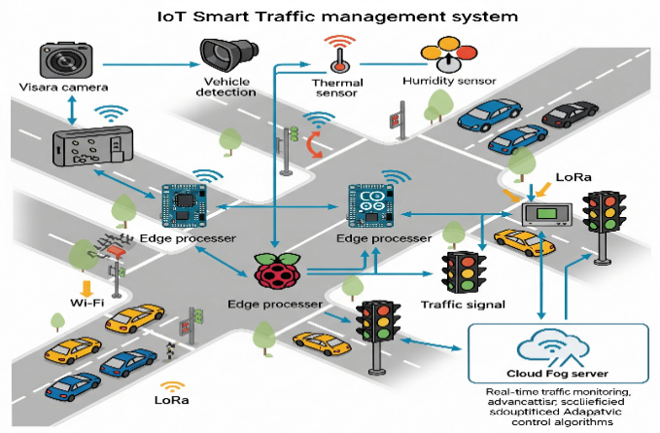congestion, the green signal duration increased accordingly to clear the way for an ambulance.Another primary application involves in emergency vehicle detection and it gives priority to them. In city environments, delays in the movement of ambulances, fire trucks, and another emergency response units may face crtical situation due to traffic congestion. To address this, our system collaborates with a dedicated transmitter-reciever mechanism. Each emergency vehicle is fitted with alow-power transmistter, while the traffic intersections are equipped with corresponding recivers. When an emergency vehicle is within a predefined zone aroung 200 meters from the intersection-the driver can activate the transmitter, which sends a signal to the receiver embedded in the traffic control system. When this signal is sent to the traffic system, it knows that an emergency vehicle will be coming up in a certain lane.This starts a chain of events that change the traffic light so that the emergency vehicle gets priority by making the green light last longer. At the same time, traffic lights in the other or intersecting paths are stopped briefly to clear the way. This is a practice that ensures the vehicle is correctly detected, has less delay, and the way is cleared smoothly, which helps in traffic flow and shortens the time for emergencies to be handled. Additionally, since the system works well under all weather condition.Intelligent signal switching, the third key application, utilizes sensor information and real-time figures to upgrade activity light administration. In differentiate to frameworks dependent on fixed cycles, smart signal switching frameworks adjust signal stages powerfully according to real-time traffic request, path utilization, vehicle categories, and climate factors. This not only enhances travel lengths but moreover reduces fuel utilization from sitting cars, specifically helping urban sustainability activities. Moreover, input from signal switching can be observed and utilized for long-term traffic design evaluation and arrangement detailing.By joining edge computing, adaptive sensors, and intelligent calculations, the complete framework becomes adaptable and responsive. The measured engineering supports staged deployment, starting with high-priority areas such as accident-prone intersections or roads around hospitals and continuously expanding to city-wide systems. In addition, with a few processing done at the edge, the framework continues to operate even when there are temporary disturbances in cloud network. This combined approach moreover gives privacy and information protection as not all natural data should be sent to the cloud.To illustrate the complete arrangement, a conceptual IoT architecture diagram (portrayed in Figure 3) is utilized, highlighting the interaction among environmental sensors, vehicle detection units, edge preparing units, signal controllers, and cloud/fog servers. Each layer of architecture has a particular but strong part in ensuring a consistent and smart traffic encounter. This collaborative and multi-layered system serves as the technological basis for real-time adaptive traffic control and emergency path management in intelligent urban areas.

**Fig. 3.** *Conceptual IoT Architecture of the Traffic System were generated using AI*

In general, IoT-based shrewdly activity frameworks hold a progressive capability to improve versatility inside urban situations, cut down on crisis reaction time, and increment the in general proficiency of the transport foundation. Whereas combining natural discernment, low-latency edge computing, and versatile decision-making, they have the capacity to overcome most of the restrictions of customary activity flag control. Within the taking after area, we show the state of the craftsmanship in activity observing innovation and how sensors and communication innovations include up to real-time urban activity insights.

**3. Survey of Traffic Monitoring Technologies**

Efficient traffic management in modern cities makes the necessary in integrated environment with diverse sensors, communication, and computation technologies. This section will represents the a comprehensive survey of key traffic monitoring technologies which relevant to our proposed system “*an embedded Edge-IoT architecture for emergency lane clearance using thermal and humidity-aware vision”*. As urban populations grow and vehicle registration rises, traditional traffic system works on static timers and minimal or no sensor integeration, struggle to accommodate the dynamic nature of the smart city. The number of vehicle registered has grown from under 50,000 in 2000 to over 325,000 in 2020, clearly explains the burden placed on outdated traffic infrastructures. This rapid rise in vehicle count signals an urgent need to change this traditional systems to smart system, real time adaptive traffic management system. Such system need to integrate with advanced technologies like thermal imaging, humidity sensors, and edge computing to ensure safety, efficiency, and emergency response during in high congestion traffic environments.

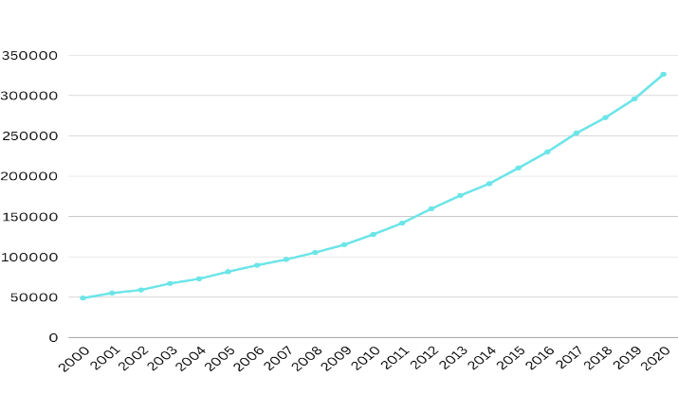

**Fig.1**. *Growth in registered vehicle count (2000–2020), highlighting the unsuitability of traditional traffic systems in managing modern urban traffic loads.*

**3.1 Detection Methods**

**3.1.1 Infrared (IR) Sensors**

Infrared has been commonly used in traffic system for vehicle detection based on heat signatures or interruptions of IR beam. These sensors offers a several use cases like low power consumption, compact in form, and ease of integration. IR sensors plays a major role in scenarios where visibility is low due to the environmental factors such as fog or mist, which makes them highly suitable for low-light traffic monitoring. IR sensors will not tell the difference between the types of vehicles or correctly measures the speed of the vehicle and it cannot detect the direction of the vehicle without any extra processing units. In our traffic system, IR sensors are used as an additional way to help find objects which RGB camera couldn’t process it.

**3.1.2 RGB Cameras**

Traditional RGB camera are widely deployed in traffic surveillance for real time video processing, license plate recognition (LPR), and vehicle classification. These cameras are advantages in high resolution image and ability to perform deep learning based upon detecting object and tracking. However, their performance worsen under poor lighting, dense fog, or rain. To overcome these limitations, we integrate humidity sensors that dynamically process environmental conditions. When low visibility is detected, the system changes to alternate imaging modes( for example:- thermal imaging), it ensures vehicle detection and classification without any interruption.

**3.1.3 Thermal Imaging Cameras**

Thermal cameras can be operated by capturing the infrared radiation emitted by objects, thereby enabling the clear vision in darkness, fog, or smoke. This is crucial in emergency situation such as fire accidents or extreme weather conditions where visibility based on heat signatures, enabling strong tracking of emergency vehicles without any interruptions. In our design , thermal imaging is dynamically activated when the humidity and temperature sensors detect visibility under certain conditions. This switching capability enhances the responsiveness in our traffic monitoring systems.

**3.2 Communication Technologies**

**3.2.1 Vehicle-to-Infrastructure (V2I)**

V2I type communication will play a major role in smart transportation systems, it enables the vehicles to share its real time status updates such as location, speed, emergency status with near by traffic intersection units or roadside units (RSU) or traffic control centers. This data exchange is essential for emergency vehicle prioritization, managing congestion, and adaptive traffic signal control. In our architecture, V2I communication enables emergency vehicles to transmit traffic clearance request directly to the system edge controller, triggering the dynamic lane clearance protocols via embedded logic at the traffic intersection.

**3.2.2 Zigbee**

Zigbee may be a low control, low information rate remote communication convention thought for interfacing different roadside sensors and actuators in a work systems. Zigbee low inactivity and proficient energy utilization make it reasonable for genuine time event notice from distributed sensors hubs for example IR and humidity sensors to a local edge computing unit. Our framework leverages Zigbee for communication between ground level sensors and edge controllers, ensuring way better transmission of natural conditions and traffic density information.

**3.2.3 LoRa (Long Range Radio)**

LoRa offers long extend, low control wireless communication, especially advantageous for wide range traffic observing where web connectivity may be conflicting.Its versatility and ability to penetrate objects make it an excellent option for conveying aggregated data from distant or high-altitude sensors to central servers or cloud hubs. LoRa will acts as the major backbone of our IoT architecture , for transmitting data from thermal cameras and humifity sensors to sense fog computing units for support analysis and decision-making.

**3.2.4 Wi-Fi**

Wi-Fi enables quick communication over a short range. Wi-Fi is employed where high-speed data transfer is significant, such as live video streaming of traffic cameras to local servers. Wi-Fi seeks more energy than Zigbee and LoRa but it is suitable for information extensive uses such as like thermal camera video analysis. In our system, Wi-Fi is implemented to connect the high definition RGB camera and thermal cameras to computer system to perform real-time image and emergency detection processing.

**3.3 Asset Types in Traffic Monitoring**

**3.3.1 Cars and Private Vehicles**

Most traffic in cities is made up of vehicles, which should be monitored at all times to manage congestion and detect abnormality such as dangerous driving or incorrect lane usage. AI models operating at edge nodes perform real-time vehicle tracking and identification from camera images, enabling unobstructed traffic flow and rule-based signal control.

**3.3.2 Emergency Vehicles**

Ambulances, fire trucks, and police vehicles are given prioritized by traffic systems intelligent. rapid path detection and path clearance are essential to save peoples lives and avoid intersection in emergency situations. Our system prioritizes emergency vehicle detection using thermal and V2I inputs and adaptively controls traffic lights and lane barriers to grant clear passage.

**3.3.3 Public Transit**

Buses and other public transport vehicles play a significant role in urban mobility. The real-time tracking of public transport helps in traffic optimization, enhances commuter satisfaction, and aids in scheduling. Our system detects buses on the basis of distinctive thermal profiles and gives priority to buses at specific junctions, particularly during peak travel times, without affecting emergency lane logic.

**3.4 Role of Edge and Fog Computing in Traffic Signal Control**

The implementation of the edge and fog computing in traffic systems abolish the drawback of conventional cloud-based systems by bringing intelligence to the vicinity of data origin points. Decentralized computation is the only model that can be adopted for low-latency decision-making, most importantly during emergency scenarios where milliseconds count.

**3.4.1 Edge Computing**

Edge nodes are located near traffic intersections or traffic poles. They perform computations on data from the surrounding cameras and sensors locally. The nodes employ simple AI models to recognize cars, monitor traffic congestion, and react to emergency signals locally. Edge computing will allows the modification in traffic lights and clear lane without the involvement of remote servers.We use Raspberry Pi or Arduino Uno and similar devices at each big intersection to analyze thermal images, check humidity levels, and control traffic on their own.

**3.4.2 Fog Computing**

Humidity sensor computing is in between the edge devices and the cloud. It will perform more advance analysis and it will assists to control the multiple intersections simultaneously. It collects the data from several edge devices, understands its traffic patterns over a period of time, and makes better control plans based on collected historic information. Fog computing within our system supports long-term traffic planning and policy adjustment based on necessity. This includes adjusting emergency clearance plans according to daily traffic analysis and locations where traffic congestion is prevalent.

This projects shows the need of utilizing numerous implies and levels to make strong traffic observing systems. With the combination of different location implies, communication implies, and computing modes, our Edge-IoT design supports emergency paths clearing at an effective pace in urban cities. The integration of warm and humidity-sensitive vision and edge and mist computing could be a modern benchmark for urban traffic management that is flexible.

**4. Predictive Models for Traffic Flow Forecasting**

In smart cities, predicting traffic flow was the serious component in traffic management. Accurate predictions helps in adaptive signal control, it avoid traffic congestion, and gives priority to the emergency vehicle. This section will discuss about various predictive models, categorized by classical statistical method, machine learning algorithms, and using deep learning approaches. Every technique offers distinct benefits and certain compromises regarding complexity, precision, and the potential for real-time usage.

**4.1 Classical Models**

Classical models will go for statistical approaches based on past traffic data to predicts the future trends. These models are simpler and easier to process and it was suitable for basic traffic flow.

**4.1.1 Moving Average**

The Moving Average (MA) technique is the simplest methods for predicting time series data. It functions by averaging data across a defined number of over a period of time, which reduces short term variations and highlight long term trends. For example, if vehicle counts at a junction are logged every 5 minutes, a 3-point moving average will calculate the average of the last three intervals to predicts what next. While straightforward, this approach is most effective for consistent traffic flows and lacks adaptability to unexpected situations such as obstacles or emergencies.

**4.1.2 ARIMA (AutoRegressive Integrated Moving Average)**

ARIMA is a advanced time series model that integrates the three elements such as auto regression, differencing, and moving average. This model can identify complicated traffic flow pattern by understanding the relationship among previous historic patterns. ARIMA is suitable for one dimensional traffic information like vehicle counts or average speed of the vehicle. It plays best in short term prediction but has difficulty in dealing with important changes in traffic caused by accidents, weather, or changing events. In addition, Arima thinks that linear and stable, can limit its effectiveness in real traffic control parameters.

**4.2 Machine Learning Models**

Machine Learning models are data depend techniques that can handle non linear relationships and multiple input features. These models learn from large datasets and can generalize the patterns better than classical models.

**4.2.1 Decision Tree**

Decision Tree algorithm will operate in the way by dividing the dataset into certain branched according to feauture values. While predicting traffic, input might consist of time, weather status, type of the vehicle, and day of the week. The tree framework will assist in understand the logic behind prediction, which was benificial for city planners. However, decision trees can overfit the training data and produce irregular prediction if they are not pruned properly. Nevertheless, they are very easy to implement and perform effectively for small scale or localized traffic prediction issues.

**4.2.2 Random Forest**

Random Forest is a collective learning approach that relies on various decision trees. It enhances prediction accuracy by merging the results of multiple trees, with each trained on a random portion of the data. This diminishes overfitting and enhances generalization. In the traffic control management , The random forest model was more efficient at predicting traffic congestion or vehicle flow in traffic control framework because it could handle the both numerical and categorical types of input. It is suitable for real time modernized smart city applications because in the way it performs well even when working with incomplete or uncertain data. While it Compared to single-tree models, the major disadvantage is it has the increased computational complexity.

**4.3 Deep Learning Models**

Deep learning models was the subset of machine learning , are capable of capturing the highly complex patterns and interactions from more amounts of data. These models are often particularly suited for the traffic applications involving the image processing, video feeds and time series prediction.

**4.3.1 CNN (Convolutional Neural Network)**

CNNs are widely used in image based traffic detection systems. They were vey good at recognizing geometrical patterns, making them as model for analysing camera inputs from traffic intersections. A CNN can detect vehicle types, traffic congestion, which path using, and also identify emergency vehicles in real time. In our model, CNN models can process both RGB and thermal camera and humidity sensors data to enhance the vehicle detection under various weather condition and with lighting or without lighting. This model extracts the features such as vehicle shapes, their positions and movements, and enabling accurate real time monitoring. CNN based models are required in large datasets for training and are computationally strong. Therefore, in our traffic system, CNN will runs on edge devices such as Raspberry pi or Arduino Uno which produce the low latency response.

**4.3.2 LSTM (Long Short-Term Memory Network)**

LSTM is type of Recurrent Neutral Network intended to understanding long term relationships in succussive information. It is especially useful for predicting traffic movement using past trends. In contrast to ARIMA, which consumes linearity, LSTM is capable of capturing intricate, non linear connections among variable. It is capable of learning how congestion develops over a period of time and following the peak times or holiday. LSTM can handle several inputs like time, weather, event timings, and produce predictions for the future traffic situations. In our systems, LSTM models are consumed for fog nodes to collect and check time series data from various intersections. This facilitates proactive traffic management by anticipating areas of congestion and enabling proactive adjustments to signal control.

Predicting model will serves as the core element of smart traffic management systems. In our proposed system which integrates the traditional statistical models with more cutting edge machine learning and deep learning technologies, achieving a agreeable balance among with accuracy, clarity of the work in machine learning and computational efficiency. Which includes these models into a fog and edge IOT architecture facilitates dynamic signal change management and predict the traffic control, leading to enchanced safer and efficient in urban mobility.

**5. Real-Time Traffic Management: A Case Study**

To illustrate the real world use of the proposed system, we have developed and evaluated the partial prototype of our embedded edge IOT system uses the Arduino platform through the Tinkercad simulation. Although the entire implementation which includes through integration of thermal imaging, camera object detection, humidity sensing, and edge computing is aimed at a physical prototype, we executed a major part of the design that includes humidity triggered signal logic to emulate the adaptive signal actions during low visibility situtations like fog or rain.

**5.1 Description of Prototype System**

The prototype has been built using an Ardunio Uno Board, a potentiometer, and the arduino serial monitor for real time feedback. The potentiometer simulates in varying environmental humidity conditons, which allows us to model the sensor input without using the required dedicated DHT11/DHT22 module unavailable in the Tinkercad environment. The core logic which simulates the adaptive traffic control during environmental disturbances. When the simulated humidity crosses a threshold limit, the system enters “fog or mist mode,” it indicates the need to switch from standard RGB camera to thermal vision for uninterrupted detection of vehicles and emergency units. An integrated LED serves 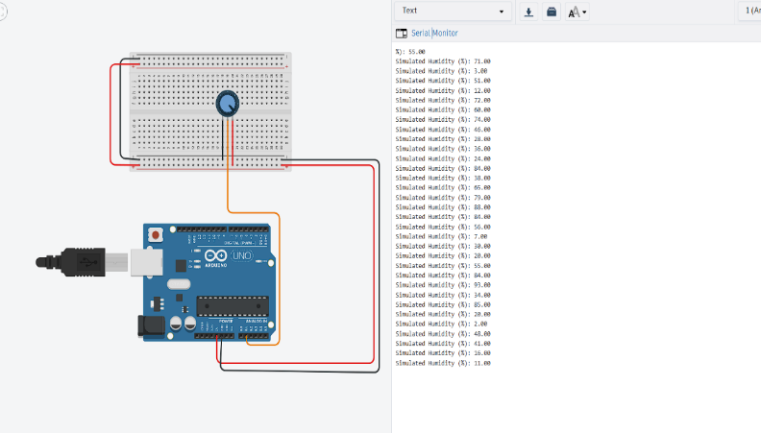as a signal to illustrate this change in system functionality. This prototype simulates a key aspect of our suggested system the automatic identification of environmental variation and the associated adjustment of sensor modes for effective emergency path clearing for vehicles like ambulance or fire trucks. Even though it is streamlined, the testbed validates the system ability to respond dynamically to environmental data using edge level processing and minimal hardware.

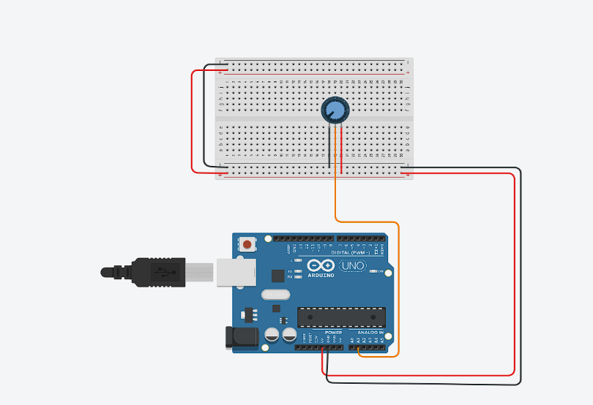

**Fig 5.1*.*** *Humidity sensing circuit simulated on Tinkercad using a potentiometer.*

**5.2 Tinkercad Circuit Design and Sensor Integration**

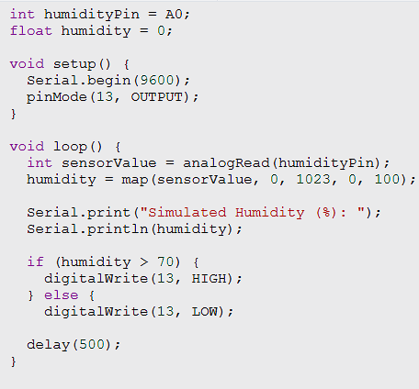In this simulated circuit, the potentiometer is wired to analog pin A0 of the Arduino Uno board. Power and ground are supplied through the Arduino’s 5V and GND pins. The serial monitor continuously reads and displays analog values from the potentiometer, mapped to represent humidity percentages. The onboard LED on pin 13 is programmed to activate the humidity crosses a threshold (70 percent), indicating environmental conditions that required thermal vision switching while implementing in real world conditions.

**Fig 5.2.** *Arduino code simulation in Tinkercad.*

**Fig 5.3.** *Serial Monitor output indicating simulated humidity levels and fog detection.*

**5.3 Adaptive Signal Control Logic – Flowchart Overview**

The complete theoretical system which incorporates not only the environmental sensing but also vehicle detection and giving priority to the emergency vehicles. The adaptive signal control algorithm it includes three core detection and decision parameters, firstly Vehicle Density Estimation( estimate via visual input), Secondly Emergency Vehicle Detection( Detect via transmitter signals or thermal imaging), thirdly Environmental Status(humidity and temperature sensing). When the system finds out an incoming emergency vehicle (within 200m), a transmitter is installed on the vehicle sends a signal to the nearby traffic pole receiver. If poor weather is detected simultaneously, the system will activates thermal cameras. If traffic congestion is high in the current direction, green light duration is dynamically increased, and opposite lanes are locked for some moment for smooth passage.

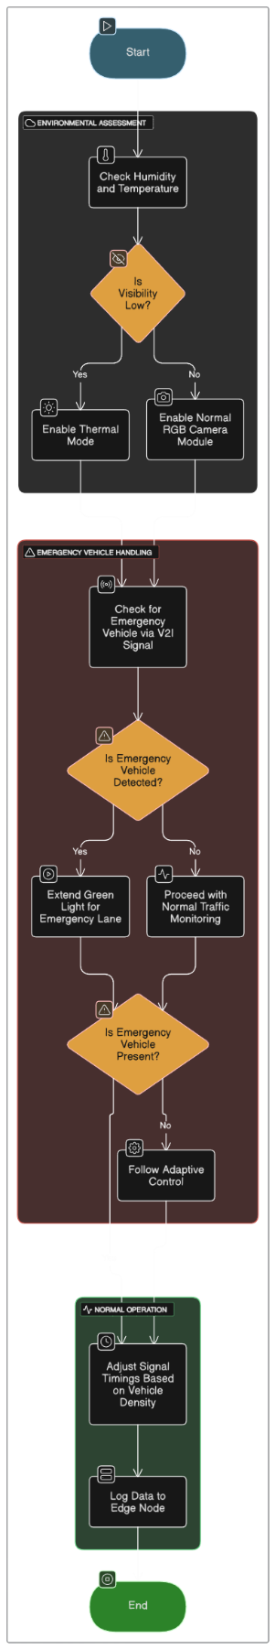**Fig 5.4.** *Flowchart of adaptive signal control integrating emergency detection and environmental sensing.*

**5.4 Toward a Full Prototype – Practical Considerations**

While the current TinkerCad prototype was successfully simulates a critical subsystem of humidity based signal triggering the full realization of our proposed system will require the integration of several advanced components and sensors. The complete implementation visualize the use of DHT11 or DHT22 sensor to provide the accurate humidity and temperature readings in real world conditions, which serves as the trigger for activating the thermal vision during low visibility weather conditions, A Raspberry pi 4 model B will functions as the primary edge computing unit, responsible for processing the data from multiple sensors and executing the AI driven decision logic with minimal time interval. For visibility compromised scenarios such as fog, smoke, or heavy rain, a thermal imaging camera will be integrated to detect vehicle heat signatures when standard RGB camera fails in that. Meanwhile, traffic signal control will be handled by an Arduino UNO microcontroller, which will execute instructions from the edge node and it will manage the real time changes to signal states. Emergency vehicle detection will be achieved using transmitter and receiver modules which are configured for the vehicles to infrastructure (V2I) communications method. When an ambulance or fire truck approached the intersection, a dedicated transmitter installed in the emergency vehicle will send a clearance signal to a receiver it is integrated in the traffic control unit. To enhance the operator visibility and enable the system management, a python based dashboard it may be deployed to visualizes sensors data and traffic behaviour in real time. The target deployment environment for the prototype is a four way intersection in urban places situated near a hospital an ideal use case for testing emergency path clearance mechanisms. In this environment, an IR sensor will detect the presence of general vehicle, while the thermal camera will act as a backup during the low visibility conditions. A model ambulance equipped with a V2I transmitter will act as the emergency trigger it sends the some emergency signal as waves to the receiver at the intersection traffic signal, and traffic signals will be simulated using LED indicators. The control unit will execute an adaptive signal logic that works in real time sensor inputs to give priority to emergency vehicles to clear the path, it validate the environmental conditions, and adjust signal timings dynamically. This part of the project will serves as a bridge between the real world deployment and simulation, validating the core design and offering the idea for scaling this traffic system across multiple urban places intersections in a city wide infrastructure.

This case study will provide the solid foundation for the proposed Embedded Edge IoT system by certifying key design components in a simulated environment. By focusing on environmental adaptability and low time period decision making, the prototype confirms its efficiency of transition from traditional fixed RGB camera traffic systems to intelligent, dynamic and safety focused adaptive traffic control administrations. The next stage will involves in extending the prototype to include thermal and V2I integrations in physical hardware for real world validation and potential city- wide deployment.

**6. Conclusion and Future Scope**

**6.1 Summary of Contributions**

This paper presented the design and partial implementation of an Embedded Edge IoT system for real time emergency path clearance in urban or smart cities. Our goal was to defend a growing and critical challenge in urban mobility. Which ensures the rapid and unstopped movement of emergency vehicles in highly congested traffic environments, especially under poor visibility conditions such as fog, mist or rain. This system integrates several core technologies, including the humidity sensors, thermal imaging, edge computing, and V2I communication. Each module was processed and discussed in the part of a smart intersection, where real time decisions are important for dynamic signal control. Through prototype implementation and simulation in Tinkercad and Arduino Uno, we just explained how humidity reading can be processed from the real time and we shift from standard RGB camera to thermal mode, we ensures an uninterrupted detection and classify the types of vehicles. Moreover, we designed emergency detection logic using simulation transmitter-receiver signaling and also showcased a basic adaptive signal behaviour based upon the sensor inputs. In section 5, a case study was overview to explain our practical approach toward understanding the system. Although we couldn’t fully integrate the all hardware components in Tinkercad, the logical design and modular flowchart will explains how each subsystem interacts with real world deployment. By combining DHT11 based environmental sensing with LED signaling and edge computing logic on Arduino Uno, we have created the foundation that can be possible for implementation into physical prototyping using Raspberry Pi, other hardware components and real urban intersections. The major contribution of this work lies in the strong weather conditions, in a short period of time clearing the path for emergency vehicle, which differentiate it from existing traditional traffic management systems that depend heavily on static timers or the decision making was centralized. This will focus on edge intelligence minimizes response time, while this architecture has been developed for tailored deployment at both high priority intersections (near hospitals, fire stations) and regular urban traffic zones.

**6.2 Scalability for City-Wide Deployment**

While our prototype was designed for a single intersection, the systems architecture is basically scalable. Each intersection can be treated as an independent edge node, it can be capable of handling its own sensing, and decision making. This prototype was unlike centralized it design reduces depend on central command unit and prevents bottlenecks. In a city wide deployment scenario, these edge nodes it can report periodic metadata to a central fog server for urban planning analytics, it identify traffic patterns of historical data, and coordinated traffic response strategies during festivals or emergencies. Moreover communications protocols like LoRa, used in our design , and it is suitable for long range, low bandwidth communication which was ideal for large scale deployment without requiring extensive 5G infrastructure. V2I communication modules installed on the emergency vehicles can be authenticated and priority handling at each intersection. By improving cloud dashboards, city officials can be monitoring the traffic signals remotely, verify path clearance logs, and issue alerts or policy overrides in the real time. Our system will necessarily fits into the wider vision of Smart City Infrastructure, it enables dynamic responsiveness and scalability without any extensive redesign.

**6.3 Future Enhancements**

The proposed system opens several significant method for the future enhancement, both in terms of hardware sophistication and software intelligence. One of the primary advancements which involves thermal vision it was optimizing through machine learning. In the current implementation, the mode switching from standard RGB to thermal vision is purely based upon the humidity limits. Future improvement will integrate AI models which can be capable of analyzing parameters such as image contrast, lighting in ambience, and historical trends based on visibility, which allows the system to switch camera modes accurately and this transition only available only if necessary. plus, to prevent false V2I communication signal triggers, emergency vehicle authentication will be embedded. We can achieve this by embedding the cryptographic keys or RFID based indentification in the transmitter components of emergency vehicles such as like ambulance and fire trucks, ensuring that only high priority units like ambulances or fire engines can be approved for lane clearance request . The implimentation of drone based technology for aerial surveillance is another exciting development. Large or crowded intersections which cannot be managed by normal camera so that we could be monitor by drones fixed with infrared sensors and ground facing cameras. These drones can transmit the real time aerial image data to edge nodes for update of situational awareness, detecting crowd, or verification of the vehicle movement. plus, cloud AI models can predict traffic patterns using advanced predicting methods like LSTM or ARIMA these are currently used in simulation can be implemented to expect traffic jams or emergency trends. This type of prediction can helps to maximize emergency lane clearance before it occurs any cause. Multiple intersection coordination can be developed for system improvement wider, allowing following intersections in the predicted path to be dynamically prepared and coordinates signals to create a perfect green corridor when one intersection detects any incoming emergency vehicle coming in its way. At last, for an energy considerations, we can add the solar powered modules and AI based power management which it can rapidly lower operating costs and improves maintainability, making the system not only effective but also ecologically conscious for broader development in urban deployment.

**6.4 Closing Remarks**

As urban populations grows rapidly and cities struggle to meet proper transportation and emergency demands in responsiveness, this works applies in the groundwork for a modular, intelligent, and practical solution that can be adaptable for real world complexities. By combining all these AI, IoT, embedded systems, and edge computing with city traffic challenges, the project explains that affordable and scalable innovations that can emerge from foundation prototyping and vision driven design. Our future work will include complete hardware implementation, outdoor testing, and benchmarking the performance under varying traffic and weather conditions. This research marks a meaningful step toward next generation traffic systems thatnot only respond in real time also it can predict, adapt, and give priority for human life.

**References**

1. Raspberry Pi Foundation. Raspberry Pi 4 Model B Documentation. Available online at https://www.raspberrypi.com/documentation/computers/raspberry-pi.html

2. FLIR Systems. FLIR Lepton Thermal Camera Module Technical Datasheet. Available online at https://www.flir.com/products/lepton/

3. A. Zanella, N. Bui, A. Castellani, L. Vangelista, and M. Zorzi.internet of things for modern cities. IEEE IoT Journal, Vol 1, Num 1, Pages from 22 to 32, February 2014. DOI 10.1109/JIOT.2014.2306328

4. S. Raza, L. Wallgren, and T. Voigt. SVELTE Real-Time Intrusion Detection in the Internet of Things. Ad Hoc Networks, Volume 11, Number 8, Pages 2661 to 2674, November 2013

5. T. Litman. Autonomous Vehicle Implementation Predictions. Victoria Transport Policy Institute, 2023. Available online at https://www.vtpi.org/avip.pdf

6. Aosong Electronics Co. Ltd. DHT11 temperature and humidity sensor datasheet. Available online at https://components101.com/sites/default/files/component_datasheet/DHT11.pdf

7. F. Chollet. Deep Learning with Python. Second Edition. Manning Publications, 2021

8. TomTom. TomTom Traffic Index 2023 Global Traffic Congestion Statistics. Available online at https://www.tomtom.com/traffic-index/

9. H. Yu, W. Zhang, G. Liu, and X. Wang. A Hybrid Machine Learning Model for Traffic Flow Forecasting Using Time-Series Data. IEEE Access, Volume 8, Pages 75015 to 75025, 2020